Dear Tenant(s),

By signing this document, you agree that the items are in your unit and are in good working order.

2-Bedroom, 2-bathroom apartment (furnished),  Inclusive of the following: |  | Unit  Number:
 |  | Mark with a tick ()
1 x Double bed per room  (137cm base set – Standard length) | 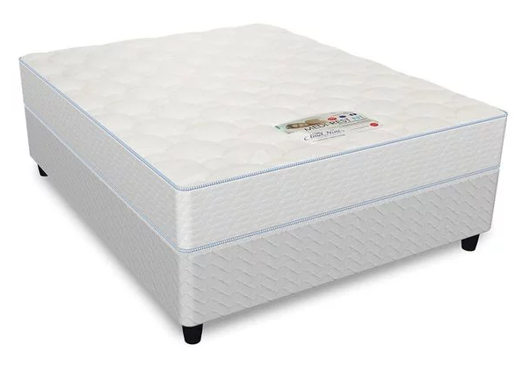
1 x Bedside table per room  (1-drawer – natural) | 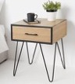 or 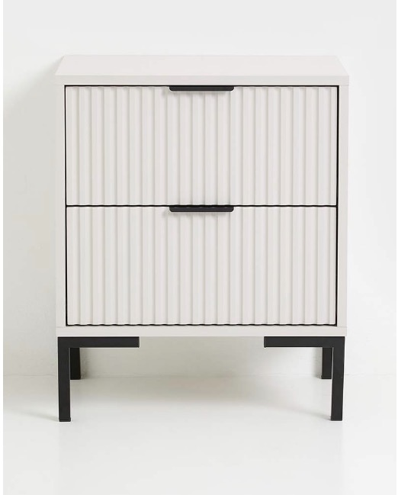
1 x L-Shape couch  (Dark Charcoal, 3000mm x 1700mm) | 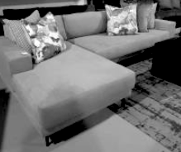
1 x Dining table  (4-seater white top with ash wood legs with metal support beams, L90xW90xH74,5) | 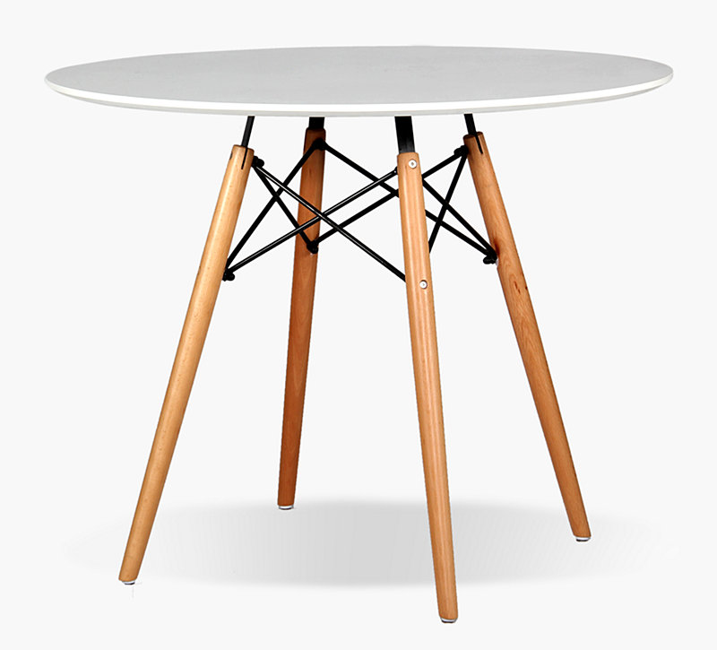
4 x Dining chairs  (PU with ash wood legs with metal support beams, L53,5xW49xH83cm) | 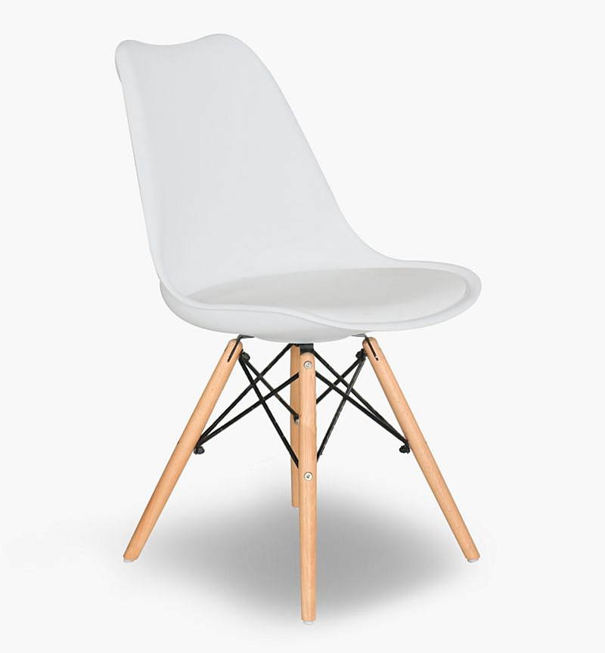
1 x Coffee table  (MDF Duco matt white, legs pine, oak stain matt seal – 900mm dia x 450mm H) | 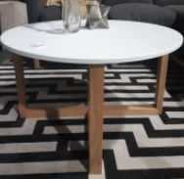 or 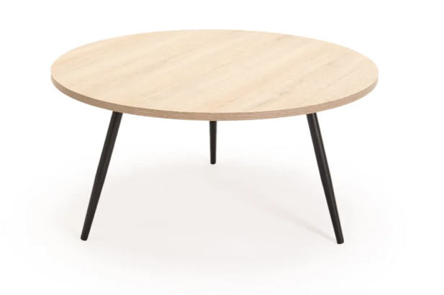
1 x Microwave | 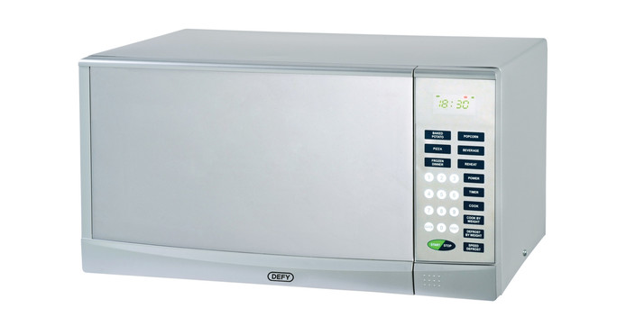
1 x Fridge  (Defy 192|Eco Combi Fridge/Refrigerator, C425-C450-C455) | 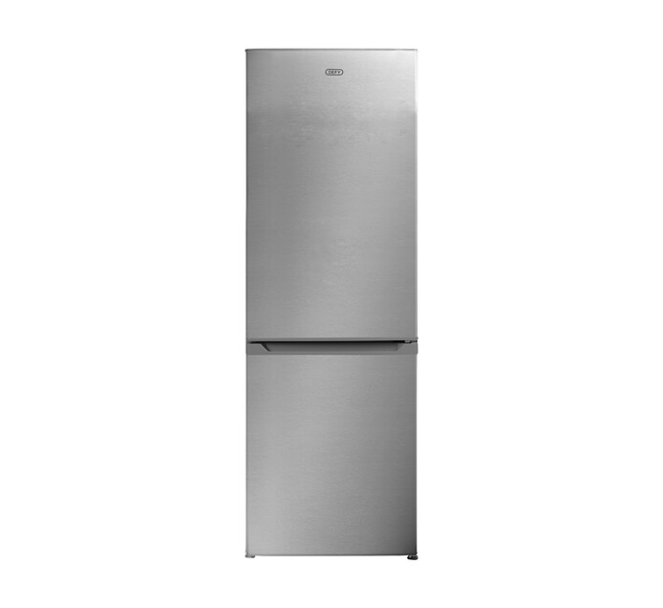
1 x HOB  (Defy Slimline NCP, DHD409) | 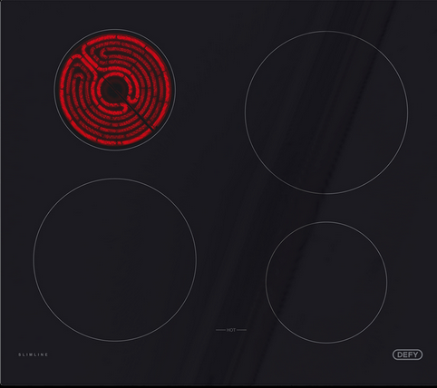
1 x Oven  (Defy Slimline 600U/600E/600SU/600SE/600ME, DBO458-DB0459-DBO460-DBO461-DBO479) | 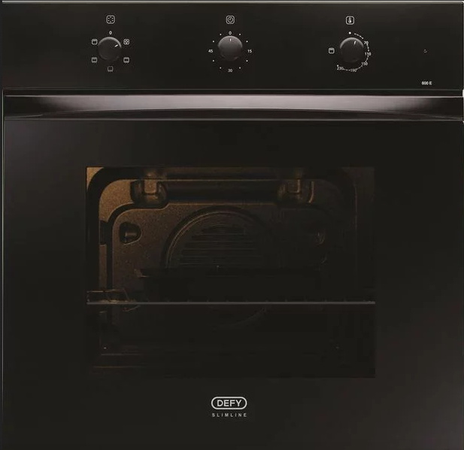
1 x Extractor  (Defy – 600 Cooker Hoods, Black) | 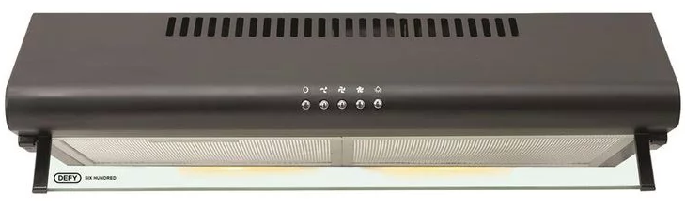
1 x Washing Machine  (Defy 6kg front loader, 92908N) | 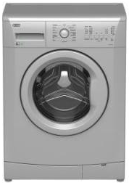
1 x Tumble-dryer  (Defy 5kg metallic charcoal tumble dryer, DTD230-DTD258-DTD259) | 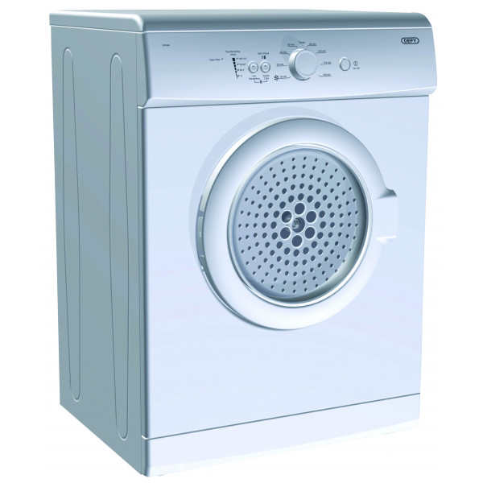
1 x 5 Program Dishwasher  (Defy DDW232, DDW230, DDW236) | 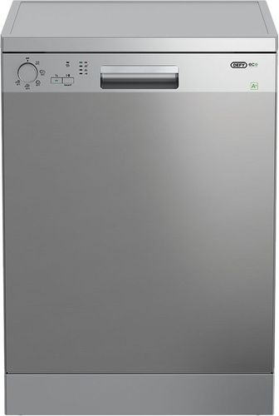
1 x Smart TV  (Hisense 55A6100 55” UHD LED TV – Smart – Mounted to wall) | 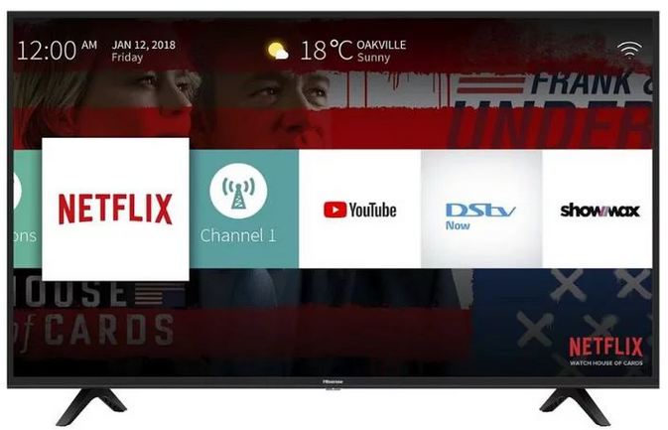
Roller blinds living room window  (2 x Bunting, White) | 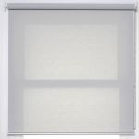
Roller blinds main bedroom sliding door
(2 x Kanga - Blockout, White)
Roller blinds bedroom 2 window
(1 x Kanga - Blockout, White)
Roller blinds on-suite bathroom window
(1 x MV Modwood, White)
Roller blinds bathroom 2 window
(1 x MV Modwood, White)
Roller blinds kitchen window
(1 x Bunting, White)
Fiber WIFI | Yes

Tenant 1

Full Name(s) and Surname: ____________________________________________________________
Date: ___________________________ Signature: _________________________________

Tenant 2

Full Name(s) and Surname: ____________________________________________________________
Date: ___________________________ Signature: _________________________________

The Aleit Academy Representative

Full Name(s) and Surname: ____________________________________________________________
Date: ___________________________ Signature: _________________________________

Witness:

Full Name(s) and Surname: ____________________________________________________________
Date: ___________________________ Signature: _________________________________

Thank You

